Upgrade IdentityIQ 8.0 to 8.1

Contents

**Upgrade IdentityIQ** 2

Shutdown IdentityIQ 2

Backup Your Existing Version of IdentityIQ 3

Download and Expand the Installation Files 3

Reapply Customization to the Upgraded Installation 6

Upgrade the IdentityIQ Database 7

Upgrade the IdentityIQ Configuration 9

Access IdentityIQ 11

**Post-upgrade Procedures** 12

Clean up IdentityIQ Tables 12

**Patch Apply** 14

Shutdown IdentityIQ 14

Download and Expand the Installation Files 14

Upgrade the IdentityIQ Database 16

Apply the Patch 17

# **Upgrade IdentityIQ**

## Shutdown IdentityIQ

We must stop all processes and shutdown IdentityIQ before performing the upgrade. Also try to schedule the upgrade for a time when the application is not being used heavily.

Check the Task Results from **Setup->Tasks->Task Results** and Report Results from **Intelligence->Reports->Report Results** to ensure that no tasks or reports are running before stopping your application server.

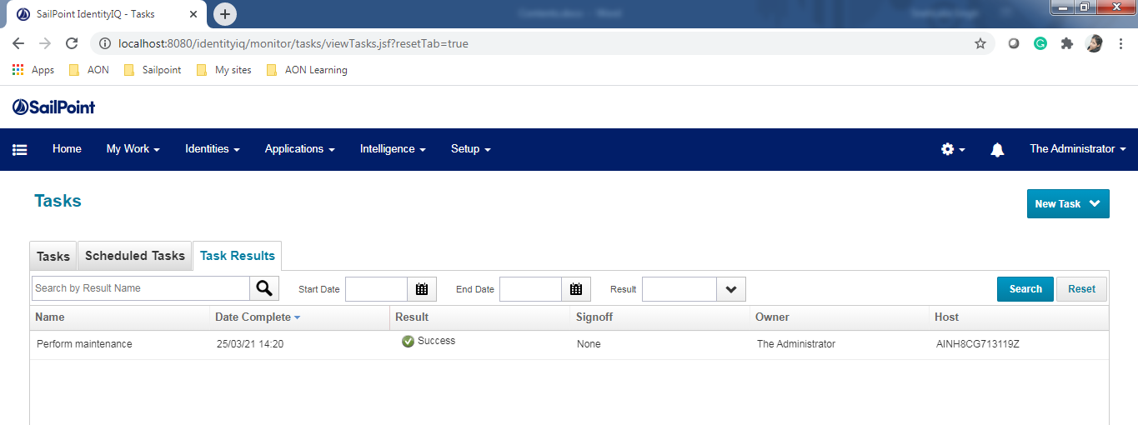

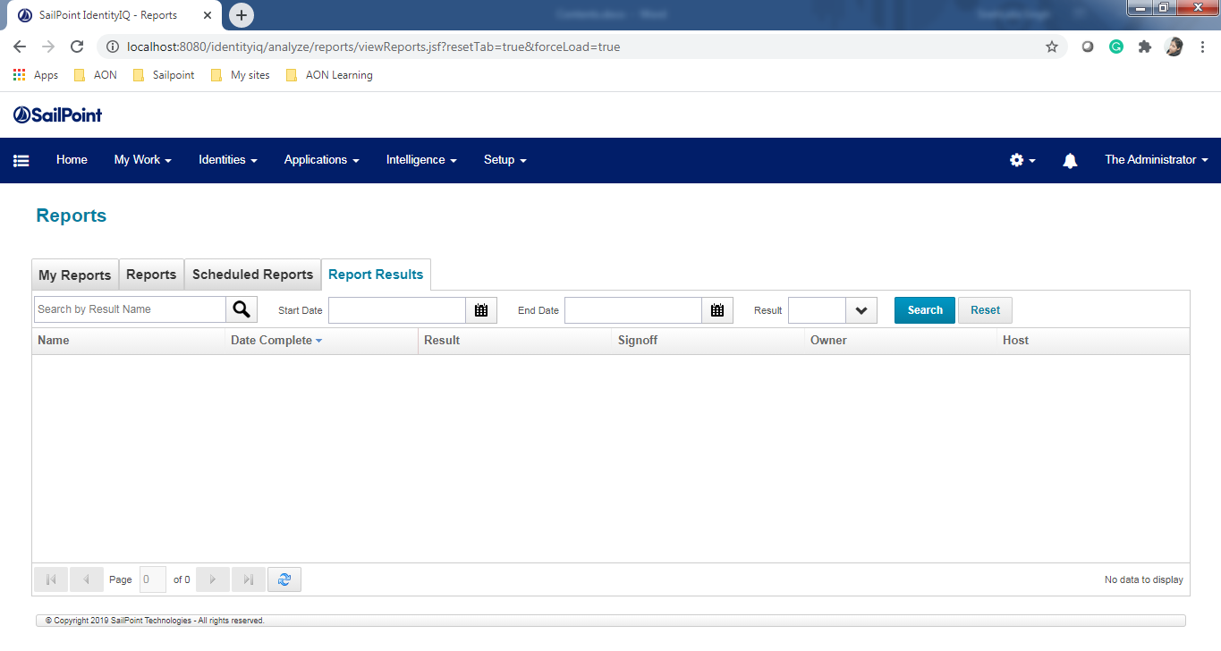

* If there are task or reports pending, terminate them within IdentityIQ before shutting down your application server.
* To terminate a task or report, right-click on the name and select **Terminate**.

## Backup Your Existing Version of IdentityIQ

We must take backup for IdentityIQ database and any customization which performed on the current installation. Any customization involving additions or changes to files in the IdentityIQ installation directory is overwritten by the upgrade procedure and will need to be reapplied when it is complete.

Customizations that are stored in the IdentityIQ installation directory can include the .hbm.xml extended attribute configuration files in WEB-INF\classes\sailpoint\object. It is recommended that create a custom directory within the IdentityIQ installation directory and copy any customized files into this directory so that we can copy and paste them back into the working directories after the upgrade is complete.

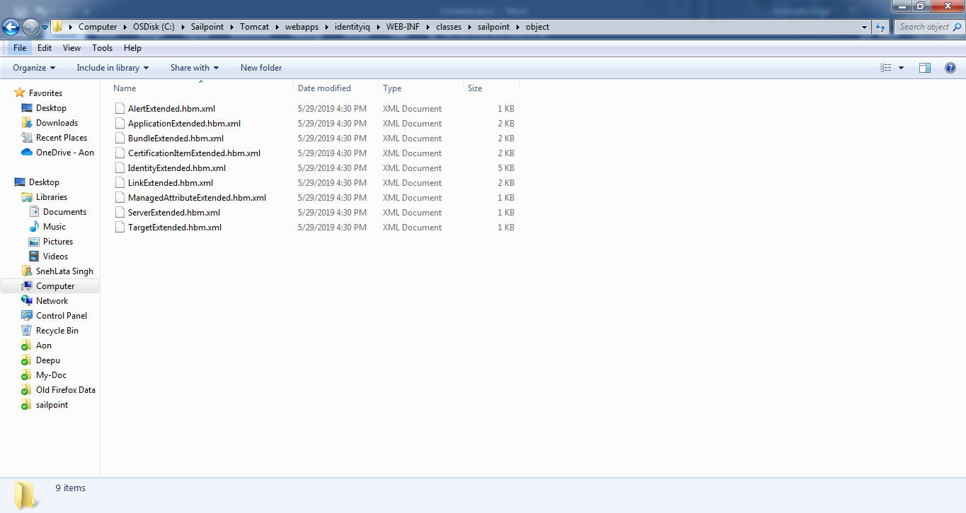

Customization also includes the task definitions, reports, rules, and workflows that are stored in the IdentityIQ database that were included as part of the product and that are overwritten during the upgrade with the latest version. If we have modified any of these, then will need to re-apply modifications after the upgrade process.

## Download and Expand the Installation Files

Prerequisite: We should have access to both the identityiq_installation and identityiq_home directories. Where identityiq_installation is the directory in which you download the installation files and identityiq_home is the directory in which you expand the identityiq.war file.

* Delete any existing IdentityIQ installation files before downloading the newest version. For Example, C:\Sailpoint\Tomcat\webapps\identityiq.
* Download the IdentityIQ installation files to a temporary installation directory on your application server. For example, C:\Sailpoint.

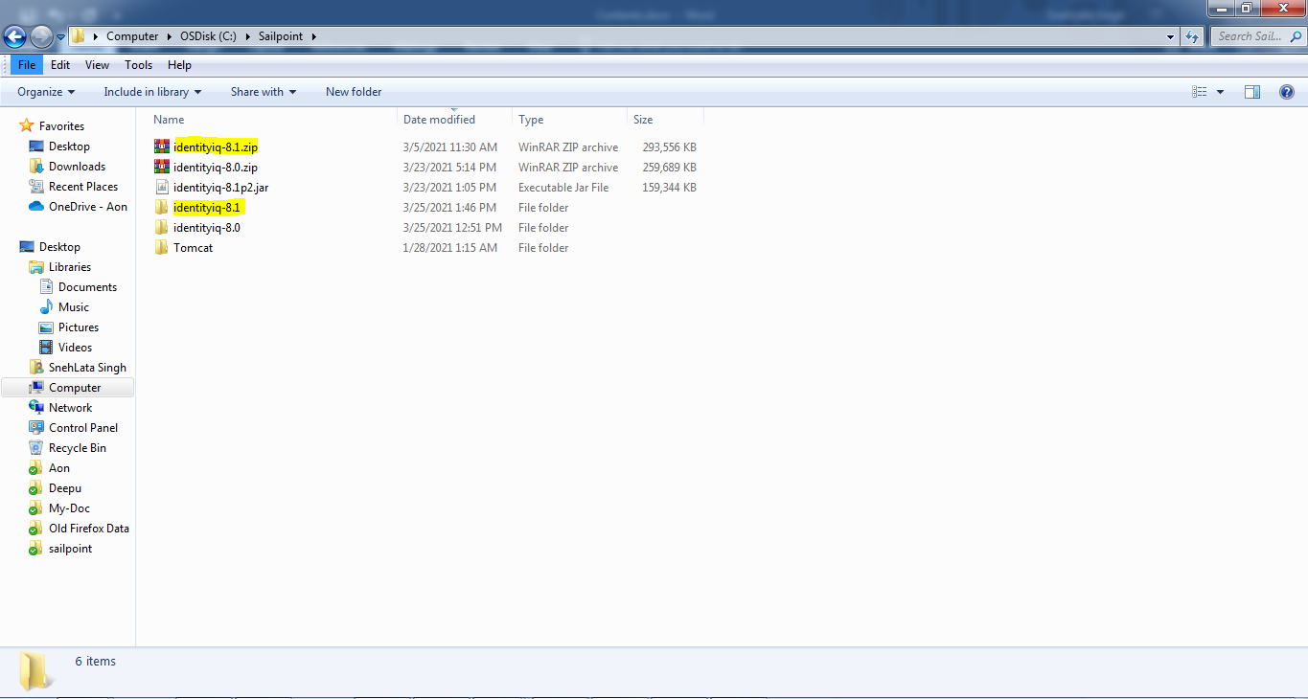

* The installation files are contained in a .zip file. The IdentityIQ installation files are as follows:

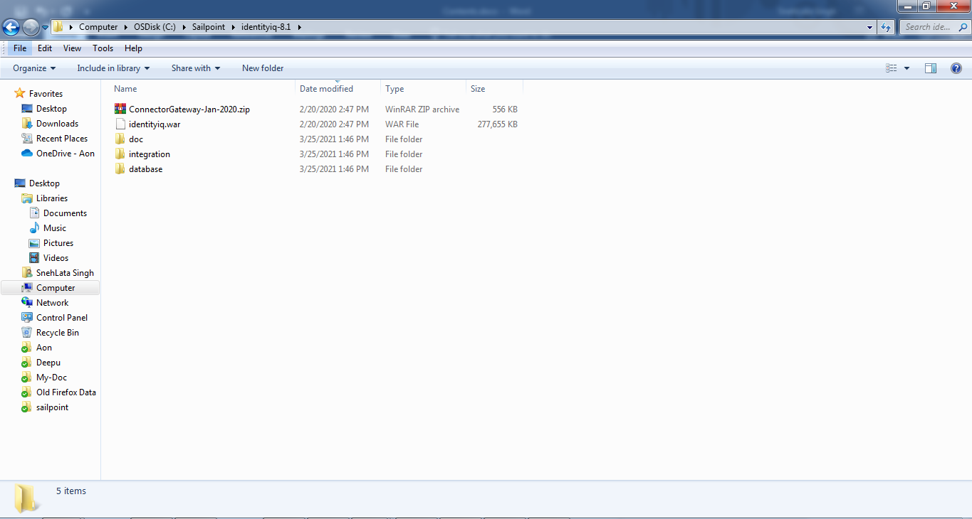

* Upgrade the IdentityIQ application on your application server. The IdentityIQ upgrade is packaged in the Java EE standard WAR format in the identityiq.war file.

We are using Tomcat to deploy a Web application by unpacking the .war file into in webapps directory of the Tomcat installation.

1. Open the command prompt and navigate to the below directory:

**cd C:\Sailpoint\Tomcat\webapps\**

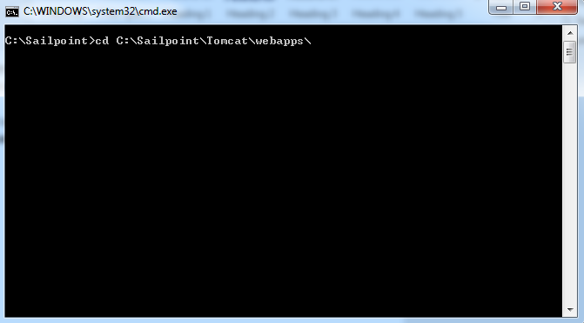

1. Access the IdentityIQ home directory:

**cd identityiq**

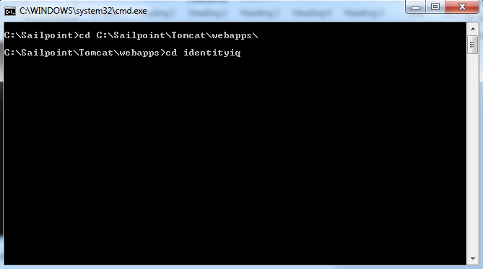

1. Delete the existing files.

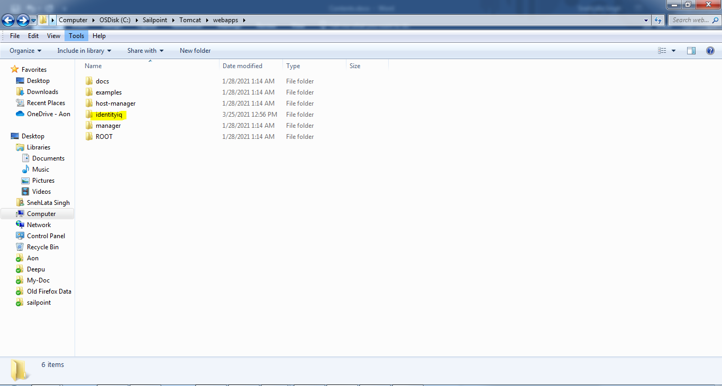

1. Expand the identityiq.war file to this directory:

**jar -xvf C:\Sailpoint\identityiq-8.1\identityiq.war**

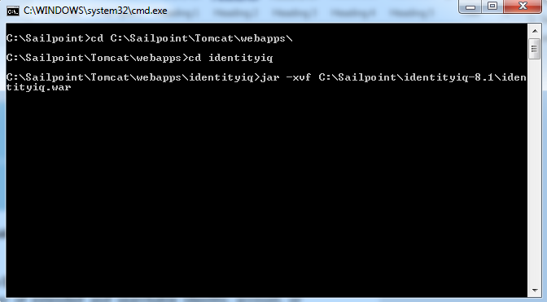

## Reapply Customization to the Upgraded Installation

If have changed the default number of extended and searchable identity, account, or certification item attributes as part of your initial installation, copy your customized IdentityExtended.hbm.xml, LinkExtended.hbm.xml, CertificationItemExtended.hbm.xml files from custom directory into the new installation.

## Upgrade the IdentityIQ Database

Execute the database specific upgrade script named **upgrade_identityiq_tables.mysql**. These files contain the DDL statements that modify the existing database schema to have the new columns/tables/etc. required for the newer version.

1. Open the command prompt and navigate to the below directory:

**cd C:\Sailpoint\Tomcat\webapps\identityiq\WEB-INF\database**

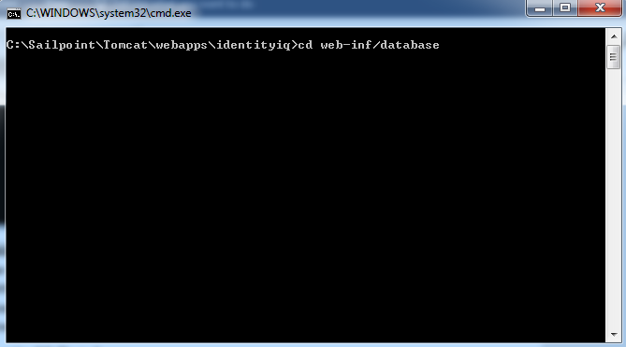

1. Then run the below command to log in the MySQL:

**mysql -u root -p**

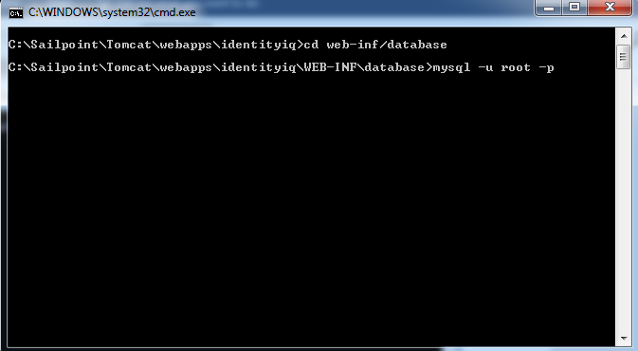

1. It will ask for mysql password, enter the password:

**Enter password:**

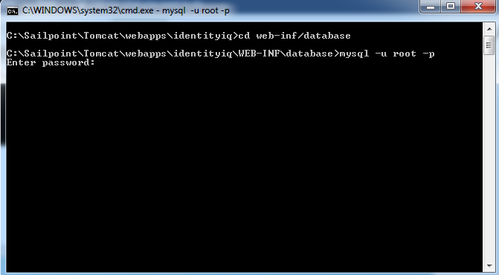

1. Within the MySQL command line utility, run the below command to upgrade the schema into MySQL:

**mysql> source upgrade_identityiq_tables.mysql**

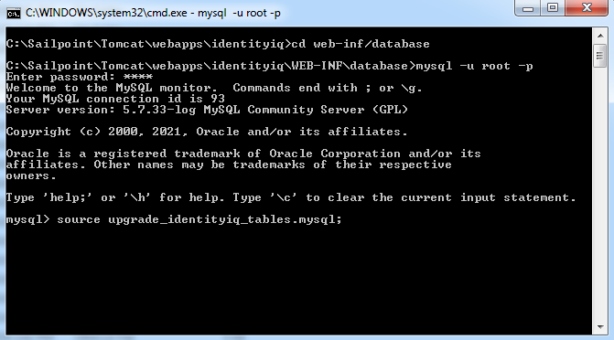

If we have installed a patch to the previous version of IdentityIQ, we could receive the following errors when running the upgrade DDL. Because the patch contains all the required changes from the base revision, some of the changes could have been applied when a patch was installed.

* Duplicate column iiqlock
* Duplicate index spt_cert_item_att_name_ci

## Upgrade the IdentityIQ Configuration

After the database is upgraded, run the IdentityIQ upgrade CLI.

1. Access the directory in which we have extracted the identityiq.war file:

**cd C:\Sailpoint\Tomcat\webapps\identityiq\WEB INF\bin**

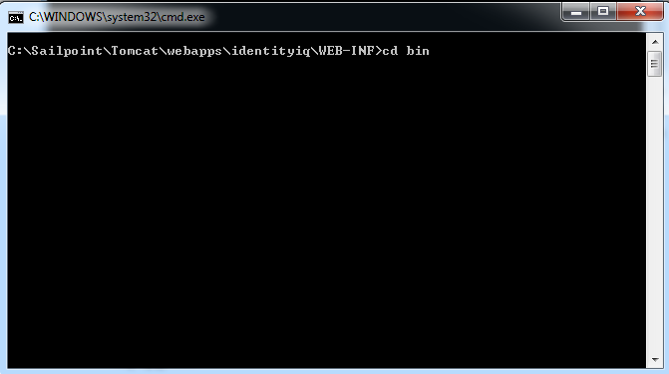

1. Run the script and command:

**iiq upgrade**

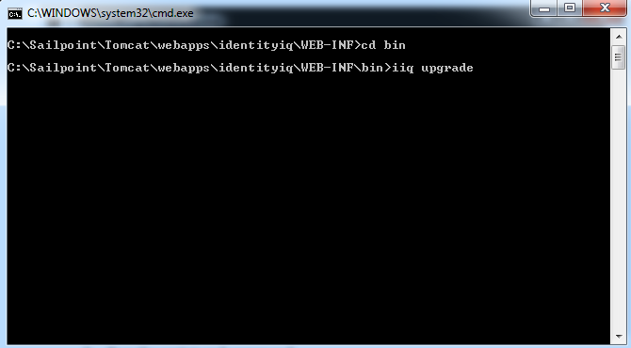

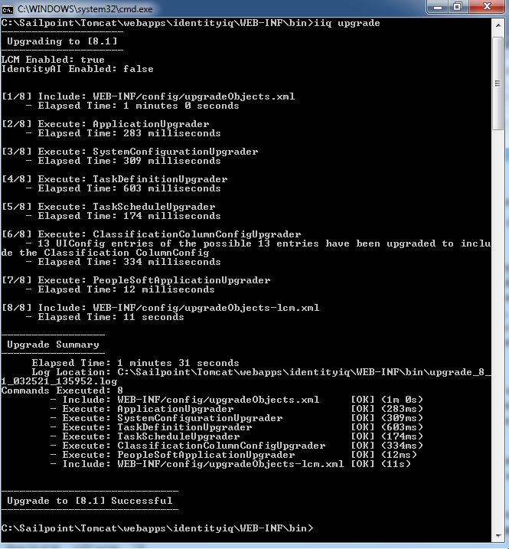

## Access IdentityIQ

Access IdentityIQ from Web browser and continue working with IdentityIQ.

1. Start the application server (or the IdentityIQ application if supported by the application server).
2. Launch a Web browser.
3. Point the browser to your IdentityIQ installation.

Example: If performed the default Tomcat installation and are accessing IdentityIQ from the same machine on which it was installed, use <http://localhost:8080/identityiq>.

1. Log on to the IdentityIQ using the default user ID and Password. The default user ID is **spadmin** and the default password is **admin**.

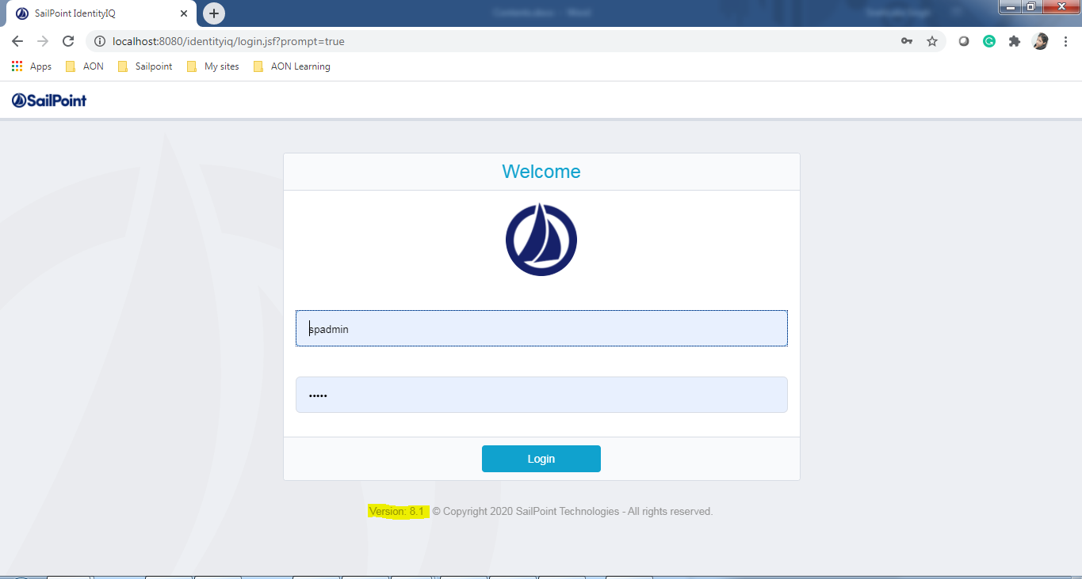

# **Post-upgrade Procedures**

After completion of the IdentityIQ upgrade and the product is up and running, perform the following procedures to ensure that all extraneous information is removed from your database tables and that all the new features are configured to run correctly.

## Clean up IdentityIQ Tables

Clean up the tables, columns, and indexes that are no longer used by IdentityIQ but that were required during the upgrade procedure with the post_upgrade_identityiq_tables.mysql script.

1. Open the command prompt and navigate to the below directory:

**cd C:\Sailpoint\Tomcat\webapps\identityiq\WEB-INF\database**

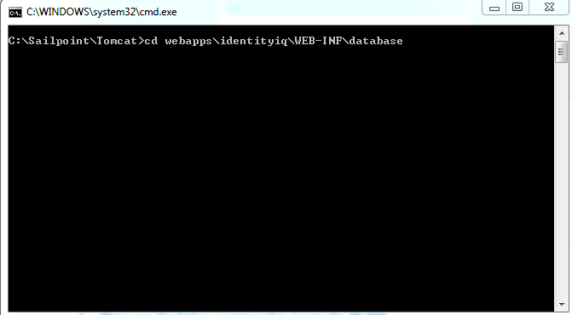

1. Then run the below command to log in the MySQL:

**mysql -u root -p**

1. It will ask for mysql password, enter the password:

**Enter password:**

1. Within the MySQL command line utility, run the below command to upgrade the schema into MySQL:

**mysql> source post_upgrade_identityiq_tables.mysql;**

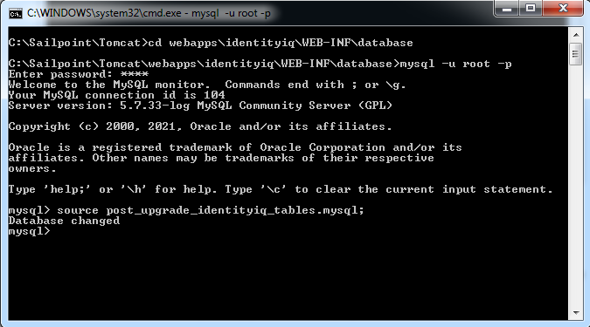

# **Patch Apply**

IdentityIQ 8.1p2 is a patch for IdentityIQ 8.1. All patches are cumulative, so this patch includes all changes from previously released patches for IdentityIQ 8.1.

## Shutdown IdentityIQ

We must stop all processes and shutdown IdentityIQ before performing the patch activity. Also try to schedule the upgrade for a time when the application is not being used heavily. Stop the application server.

## Download and Expand the Installation Files

Prerequisite: We should have access to both the identityiq_installation and identityiq_home directories. Where identityiq_installation is the directory in which you download the installation files and identityiq_home is the directory in which you expand the identityiq.war file.

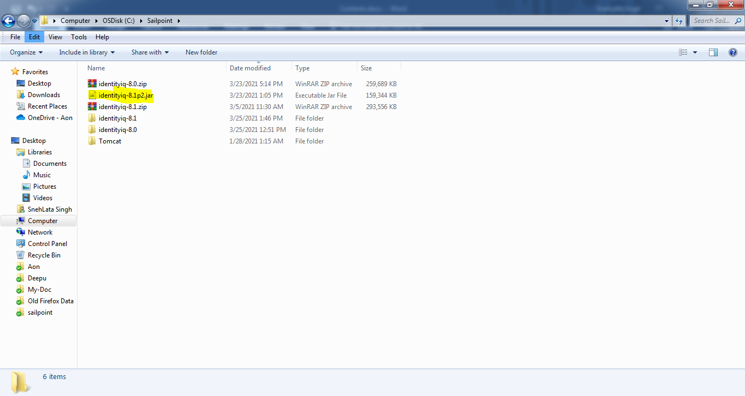

Download the identityiq-8.1p2.jar. Un-jar the IdentityIQ patch in the IdentityIQ installation directory.

1. Open the command prompt and navigate to the below directory:

**cd C:\Sailpoint\Tomcat\webapps\**

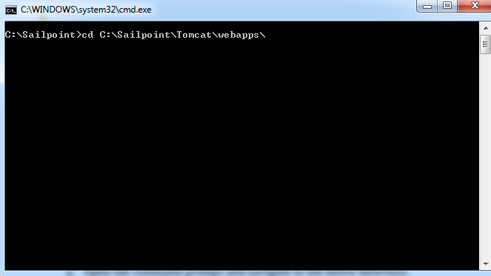

1. Access the IdentityIQ home directory:

**cd identityiq**

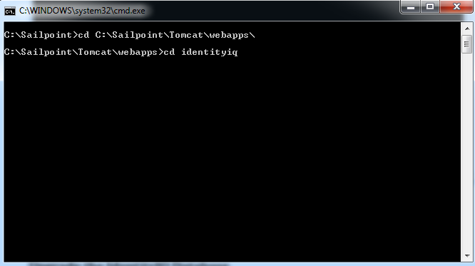

1. Un jar the identityiq-8.1p2.jar file to this directory:

**jar -xvf C:\Sailpoint\identityiq-8.1p2.jar**

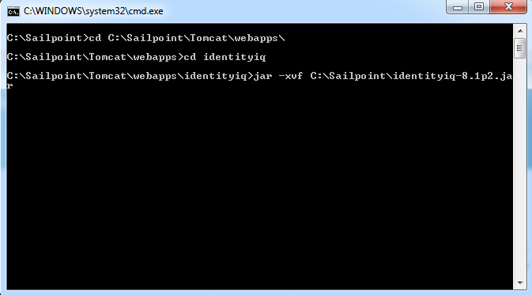

## Upgrade the IdentityIQ Database

Execute the database specific upgrade script named **upgrade_identityiq_tables-8.1p2.mysql**. These files contain the DDL statements that modify the existing database schema to have the new columns/tables/etc. required for the newer version.

1. Open the command prompt and navigate to the below directory:

**cd C:\Sailpoint\Tomcat\webapps\identityiq\WEB-INF\database**

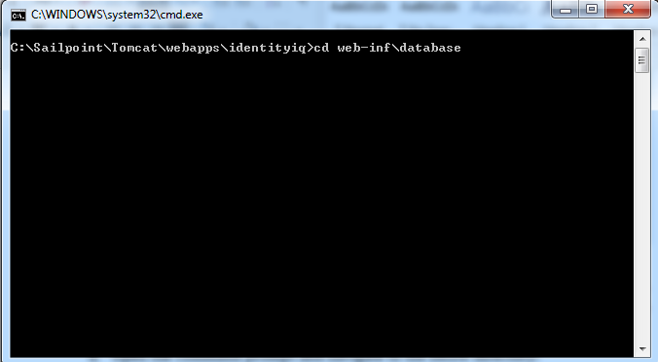

1. Then run the below command to log in the MySQL:

**mysql -u root -p**

1. It will ask for mysql password, enter the password:

**Enter password:**

1. Within the MySQL command line utility, run the below command to upgrade the schema into MySQL:

**mysql> source upgrade_identityiq_tables-8.1p2.mysql;**

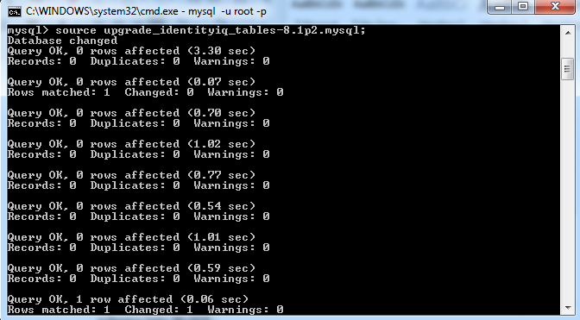

## Apply the Patch

After database upgraded, apply the patch by command line interface to execute the below command:

1. Access the directory in which we have extracted the identityiq8.1p2.jar file:

**cd C:\Sailpoint\Tomcat\webapps\identityiq\WEB-INF\bin**

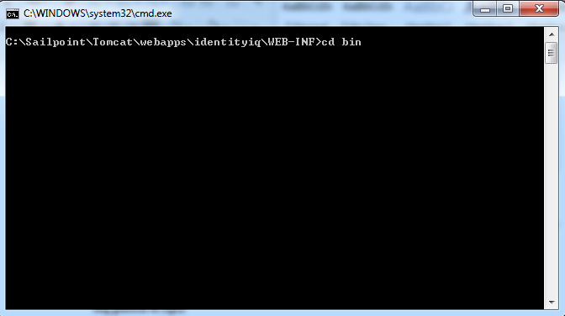

1. Run the script and command:

**iiq patch 8.1p2**

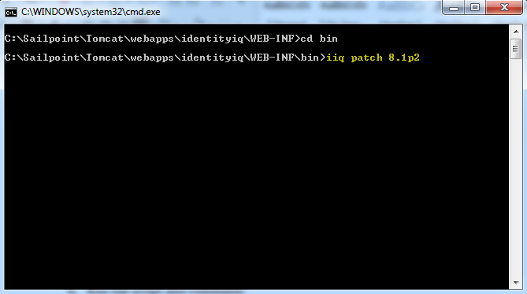

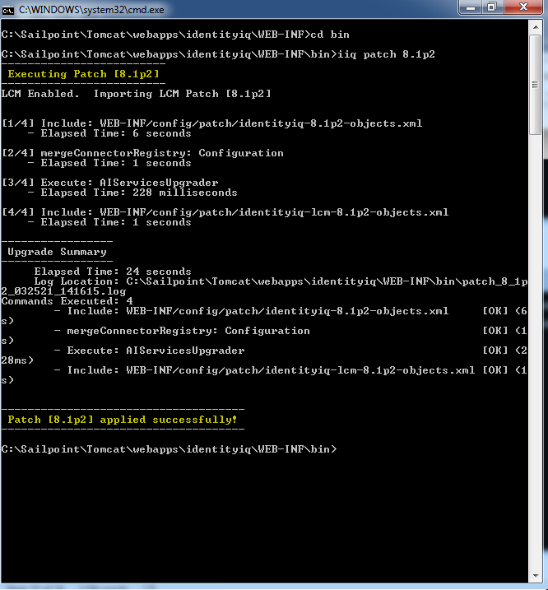

1. Start the application server

